Lucy Roberts

HC 444: Race, Science, and Literature

Dr. Angela Rovak

May 9, 2022

Out of Place:

Black counter-cartography as a form of resistance in the Jim Crow Era

The production and dissemination of knowledge is a privilege historically reserved for the ruling class. A wide range of social and economic factors– from exorbitant education prices to outright racism– have sought to preserve historic systems of knowledge dissemination in order to preserve the hierarchies those knowledge systems reify. In order to build knowledge systems within these hierarchies, minoritized groups have developed their own processes for generating and communicating information between individuals. Counter-cartography is a field which encapsulates the ways that minoritized groups conceptualize and visualize concepts of space to substantiate their ties to place. While the field of Cartography has been made more accessible in the last half-century following the invention of geographic information systems (GIS), counter-cartography has a long history of being used to challenge the power of the ruling class. The importance of counter-cartography has been particularly prudent in the fight for African American civil rights given spatial histories of oppression such as enslavement, segregation, and redlining. These counter-cartographies have taken many forms and been described in many ways, but at their core, they are ways of relaying and communicating spatial information to an audience that subverts traditional geographic preconceptions. In this paper, I will analyze how Black Counter-cartographers in the Jim Crowe era created spaces and redefined places to exert their self agency in the face of a discriminatory landscape.   
 *Cartography* is defined by Encyclopedia Britannica simply as “the art and science of graphically representing a geographic area, usually on a flat surface such as a map or a chart.” This definition is simplistic, however, in its description of what can be depicted cartographically. Cartography has been used historically to depict geopolitical *place*, or the artificially constructed boundaries and labels for physical features which define geographic areas. An example of cartographic depictions of place could include a map showing nation-state boundaries, a cartogram showing flags to represent various populations, or a navigational map with labels ascribed by politicians and people in power. Cartography can also be used, however, to depict space, which Tamara Butler defines in *Black Girl Cartography* as, “formally uncharted locations that are still inhabited, used, and created.” Butler notes in this definition that space can occur within a recognized place such as a building, ship, road, or nation, but that it can also include epistemological space within a discipline (31). With this context, Cartography can be further defined as the art and science of graphic representations of geographic concepts such as place and space, which can occur on a flat surface such as a map or a chart.

Many Black people in America have become spatially grouped in US history through coercive geopolitical practices which legislate place such as redlining, segregation, and sundown laws. In these cases, racist histories can be visualized through traditional geopolitical demarcations which have institutionalized efforts to segregate races spatially. As Butler notes, the mere existence of geopolitical locations denotes how a place gets defined on a political, legal, and ordinential level. This makes Black scholars and activists particularly interested in how geopolitical locations compound social inequalities (31-32). The historic ramifications of political legislation demonstrate how geographic definitions of place manipulate and modify Black histories. Understanding place (as a concept) and places (as nouns) can help to break down the ways that geography and cartography have been as both liberating and oppressive forces in the struggle for civil rights.

Space, as an extension of geographic place, is a social institution that heavily influences race and culture. In Valerie Kinloch’s analysis of space, literature, and youth in Harlem, NY, she describes a Black research participant, Rebekka Hogan, who used space as a praxis for understanding her intersectional identities. Hogan, a middle class worker, drew comfort from a shared skin color with her neighbors in Harlem, which was a space where she could move from a Senglese grocery store to a Dominican bakery without feeling out-of-place because of her skin color. On the other hand, her economic positionality gave her a sense of guilt as she could afford rising neighborhood prices more readily than her less-formally educated neighbors (166). Hogan’s comfort in Harlem due to her racial identity demonstrates how space and race symbiotically build and define each other. The ramifications of inter-spatial, inter-racial movement are then crucial to understand in order to better conceptualize both.

The gravitational effect that draws people together based on shared traits, like Hogan moving to Harlem to find a sense of Black community, results in spatial clustering– or the geographic grouping of similar cultures, demographics, or people– and reinforces those similarities through the development of similar cultural practices and norms. In Michelle Lanier and Allison Hamilton’s essay “Rooted: Black Women, Southern Memory, and Womanist Cartographies,” Lanier reflects on how her geographic move from central North Carolina to the Gullah-Geechee corridor shifted her personal relationship to the culture around her, “Over time, my otherness shifted. I began bonding with the land and the people– and the land and the people of the Lowcountry are intrinsically tied. I learned to move in that land and was drawn to her mysteries most of all” (14). Even though Lanier remained in the same state, or place, of North Carolina, her movement to a new cultural space redefined her relationship with the peoples and cultures near her. While her family were “beach people,” that identity was limited by her childhood spent in the land-locked central state. Lanier’s move to the Gullah-Geechee region shows how space impacts her experience of Blackness and position in a broader culture. The spatial clustering of racial groups over time shows how important conceptualizing place is in understanding and reimagining other cultural institutions.

Through these space-place-race interactions, we can see how Black geography and the Black spatial imaginary are important in informing cultural and racial self-identity. However, as Reagan Yesser and Derek Alderman note in their article, *Art as “Talking Back,”* mapmaking and cartography are fields historically cost-prohibitive to anyone except the ruling class because of the significant up-front cost of educating and training cartographers, as well as the material cost of expensive inks and papers (140). Consequently, Black cartographic traditions grew independently from traditional cartographic practices. Counter-cartography is the practice of marginalized people using the field of cartography to reassert their connection to place and space. This field can be considered the geographic extension of *fugitive science* or the adaptation of natural scientific methods to undermine racist scientific ideologies in the fight for slavery abolition (Rusert 4-5). Lanier expands pushes this definition of counter-cartography from simply undermining discrimination to an active methodology of exerting agency after a group has been disenfranchized,

If cartography is the art of creating maps, of revealing the imagined borders and renaming practices by those arrogant enough to claim domination over water and land, counter-cartographies and restorative cartographies are powerful tools for centering the marginalized and repairing the fissures between one’s ancestral landscapes and ancestral memories. (20)

Yesser and Alderman continue on to explain that counter-cartography can take one of two forms to subvert traditional norms– either the adaptation of conventional mapping techniques to reclaim space and connection to the land, or the creation of alternative cartographic forms which in and of themselves, “challenge normative ideas of what maps should look like reminding us that maps are not an ontological given.” (140). Counter-cartography is the practice of using cartographic communication to exert self-determination, either through traditional mapmaking practices or through the novel applications of cartographic concepts.

While cartography is typically associated with maps of physical space, cartographers are often tasked with *thematic mapping*, or creation of cartographic products which display and convey data. In the early 20th century, Black counter-cartographers expanded the work of Ida B. Wells to create spatial data visualizations of lynching incidence in the United States to advocate for stronger lesgislation and enforcement of laws against the murder of Black and Black-appearing people in the South. Ida B. Wells is known as highly-influential counter-cartographer, not because of any particular cartographic product she created, but because how she applied the data sciences to civil rights advocacy countered and reformed public perceptions of space, safety, and public policy:

Ida B. Wells produced an alternative public knowledge system about racism in the US Southeast—where lynching was especially frequent and brutal. She produced knowledge and projected a uniquely Black spatial imaginary, a Black sense of place, that was oppositional (a counter-map) to the social and geographic images perpetuated by white lynching proponents, or their silent accomplices, who promoted the idea of Black males as rampant rapists and murderers incapable of self-determination. (Alderman et al. 74, 2021)

Ida B. Wells contributions to counter-cartography are not just limited to her data analysis work, but expand into the ways those analyses informed and inspired later cartographers. As seen in *Appendix 1*, cartographers with Black advocacy groups such as the Tuskegee Institute and the National Association for the Advancement of Colored People (NAACP) created data visualizations of lynchings throughout the US in the 20th century. These data visualizations use common cartographic techniques such as *choropleth maps,* where geographic areas are shaded according to some data value, or *dot density maps*, where dots are distributed in a geographic area to show the relative density of incidence rates. These mapping products were widely distributed through news media and popular pamphlets at the time(Alderman et al. 140). Another variation of visualization entitled “3436 Blots of Shame” was produced by a woman named Madeline Allison, who was employed as W.E.B. Du Bois’s secretary (Alderman et al. 142.) Her map, seen in *Appendix 2,* combines a dot-density and choropleth method becausr the dots are not distributed randomly witin their geographic areas, but are positioned in the center of the states and fill the state with based on the number of lynchings that took place. The dots, colored red in some versions of the map, are positioned at the geographic center of each state– showing how each “blot of shame,” each extrajudicial murder of a Black man, is a strike at the heart of that area’s humanity. Cartographic depictions of lynchings in the mid-20th century challenged presiding narratives that lynchings were local responses to crime and painted violence against Black people as a nation-wide horror.

Louise E. Jefferson is perhaps the most prominent example of a Black cartographer who pushed cartography past the strict visualization of geographic knowledge and revitalized cartographic traditions to put Black lives, people, and stories on a map. Jefferson was an artist who trained in multimedia and fine arts at Columbia University (Yesser et al. 140). Through her prolific career, she produced a wide array of artistic maps which combined colorful geographic symbology with artful depictions of her subjects. Jefferson’s work differs from strictly data-driven cartography in that,

[t]raditional counter-maps often cover vast swaths of data and use mapping styles such as dot density, where one dot represents one data point, to map those who are overlooked. Although this allows the map to document more data points, it alienates the reader from the humanity of the subject; employing photos and illustrations in a feminist style of mapping makes the reader form more immediate and lasting empathy for the image and subject that would not be possible if the data were represented by a dot. (Yesser et al. 144)

*Feminist cartography* is a critical lens through which some cartographers challenge the traditional scientific epistemologies that reject emotion as an irrational human error, often associated with femininity. Feminist cartographers embrace the experience of emotion when observing data as equally as important as the empirical data that is being presented (Piani et al. 186-187). By integrating imagery into her narratives of space, Jefferson creates an emotional connection between the audience and the story. Where dots could represent a famous individual, adding imagery more effectively represents a story. Jefferson’s use of feminist cartography and emotional storytelling re-establish space for Black histories amidst the American landscape.

Two exemplars of Jefferson’s cartography, *Americans of Negro Linneage* and its antecedant *20th Century Americans of Negro Linneage*, are practical examples of how Jefferson claimed space for Black history through mapping it onto place. Her 1945 piece, *Americans of Negro Linneage* (*Appendix 3*) features an outline of the United States overlaid with images of Black Americans who have made history in some field. By putting Black histories on her map, Jefferson, “renders visible Black minds, Black labor, Black institutions, Black artistry, Black education, Black business, and Black lives. She roots them, places them in space, creating a testament, a transportable constellation of monuments. She declares, We were here [*sic.*]” (Lanier et al. 22). Jefferson’s use of cartography reifies Black traditions and contributions across a multitude of physical and epistemological spaces. This early map has interesting contradictions with her later iteration of the map, the 1965 *20th Century Americans of Negro Linneage* (*Appendix 4*)*.* In this iteration, the outline of the United States is moved back in the visual hierarchy and made physically smaller to make room for large black-and-white pictures of Black activists and historymakers. Instead of focusing her work solely on the contributions of Black changemakers, in this iteration Jefferson splits the geographic stories between “outstanding” men and women in their fields and images of everyday Black excellence (Yerrer et al. 143). For example, an inscription is written adjacent to a list of radio and TV educators which celebrates how,

[m]any Negro teachers, at every grade level, have given boys and girls not only knowledge but the inspiration and pride they could not get from the society around them. Now a new technique, radio and television instruction, is lengthening the voices and influence of these teachers.

In this style, Jefferson not only celebrates Black excellence, but Black life and Black being. She uses cartography as a tool to represent the vibrancy of Black life and culture. Jefferson’s cartography is a monument to remember Black histories and place them in spaces that overlap with traditional historic narratives.

The large-scale legislative and socia effort to re-establis strict racial segregation in the wake of the reconstruction area was one of the defining charactaristics of Jim Crow Era segregation. Legislators and self-appointed vigilanties prevented Black transportation through a lethal combination of legal limitations and social intimidation. To facilitate the travel of Black southerners during this time, Victor H. Green, a postal worker in Harlem, NY, compiled and published dozens of iterations of *The Negro Motorist’s Green Book*, which detailed tips, travel routes, and safe rest areas to Black travelers. He did so by leveraging his network of postal workers and encouraging Black entrepreneurs on their routes to list themselves in the Green Book. While Green’s book did not contain a singular map, it “represented a “counter-map” because the spatial data contained within it helped travelers of color move across and inhabit a not-so-open highway in oppositional ways” (Alderman et al. 69). The creation of the Green Book was an innovative example of spatial data compilation, but its dissemination was oppositional in the way it facilitated the movement of Black travelers in spaces and places they would not have been able to visit otherwise. As the Smithsonian Online Exhibit explains, “Traveling with the Green Book,Black citizens came together to eat, dance, talk, shop and relax. The Green Book pointed the way to a Black experience, not on the mainstream horizon, but it was there—real, alive, and thriving.” As this quote emphasizes, the Green Book was not designed to subvert White power structures, but to promote Black travel, Black experiences, and Black joy amidst a racist society. As Michelle Lanier’s definition of counter-cartography emphasized, Black counter-cartography was not just about subverting a White-dominated power structure, but asserting agency in the face of discrimination, and facilitating the opportunities that were systematically confiscated. *The Negro Motorist’s Green Book* is an example of how Black space and place makers used cartography to live life within a discriminatory power system.

Space and place are key domains that interact with and redefine race and racism. While cartography is the art and science of conveying issues about space and place, counter cartographers remind us that there is no monolithic way to conceive of or to conceptualize them,

Paper and screen are not enough to hold these stories. The maps must be two-dimensional, yes, but they must also be performative, aural, visceral. They must reveal the nuances and majestic intimacies of daily lives while guarding against the specters of colonial voyeurism and appropriation. . . . I envision women walking ancestral lands in pilgrimage, dancers on the battlegrounds, horns in revelry over streams that carried those running from bondage, T-shirts announcing their names, billboards shouting their legacies, more monuments, more markers. (Lanier et al. 23)

This quote serves as a reminder of the power of cartographic narratives that are told with agency– of the strength that is created and represented when historic inequalities meet the righteous power of self-determination. The cartographers who made their imprint on the geography of the Jim Crow Era still have resounding impacts on contemporary counter-cartographers. As Ida B. Wells, Maddison Allison, and the cartographers at the Tuskegee Institute advocated to preserve the rights, lives, and dignity of Black people against lynching terrors, they created the inspiration for the future cartographers who built the “Lynching in America” web mapping experience[1]. Similarly, as Victor Green enabled Black travelers to explore the United States via motorcar, he laid the groundwork for Monique Lewis to educate and expand access to global travel through her modern TV series, “The ABC Global Greenbook.” When Black counter-cartographers in the Jim Crow era redefined places and spaces to create their own self-determination, their legacies were written in the maps, stories, and geographies that reverberate and resonate through the ages. In the Jim Crow Era, Black scientists, storytellers, and innovators used counter-cartography to substantiate their ties to land where they had been left out of place.

Citations

Allison, Maddison. *3,346 Blots of Shame*. Produced for the National Association for the Advancement of Colored People. Map, 1922. Published by Rand-McNally, <<https://archive.org/details/map_1f_g3701_e625_1922_r36_01>> .

Alderman, Derek, et al. “The mapping behind the movement: On recovering the critical cartographies of the African American Freedom Struggle.” *Geoforum*, vol. 120, 2021, pp. 67-78Accessed 26 May 2022.

Butler, Tamara T. “Black Girl Cartography: Black Girlhood and Place-Making in Education Research.” *Review in Research Education*, vol. 42, Mar. 2018, pp. 28–45, Accessed 19 May 2022.

Britannica, The Editors of Encyclopaedia. "cartography". *Encyclopedia Britannica*, 16 Jan. 2017, https://www.britannica.com/science/cartography . Accessed 9 June 2022.

Jefferson, Louise E., “20th Century Americans of Negro Lineage.” 1965. *Portland State University*, accessed May 26, 2022, <https://exhibits.library.pdx.edu/exhibits/show/gates/integration/pictomap.html>

Jefferson, Louise E. *Americans of Negro Linneage*. 1946. Barry Lawrence Ruderman Antique Maps Inc, <https://www.raremaps.com/gallery/detail/65926/americans-of-negro-lineage-jefferson>

Jefferson, Louise E. *Uprooted People of the U.S.A*. US Library of Congress, accessed 20 May 2022, <https://blogs.loc.gov/maps/2022/02/louise-e-jefferson-a-hidden-african-american-cartographer/>

Kinloch, Valerie. *Harlem on our minds: Place, race and literacies of urban youth*. 2012. New York, NY: Teachers College Press.

Lanier, Michelle. “Rooted: Black Women, Southern Memory, and Womanist Cartographies.” *Southern Cultures*, vol. 26, 2020, pp. 12-31., Accessed 19 May 2022.

*Lynchings by States and Counties in the United States 1900 to 1931*. American Map Company. Data from Research Department, Tuskegee Institute. Map, 1931. Retrieved from the Library of Congress, <[www.loc.gov/item/2006636636/](http://www.loc.gov/item/2006636636/)>.

*Lynchings of Last Ten Years 1909-1918*. National Association for the Advancement of Colored People. Map, 1916. Retrieved from the Library of Congress, <http://www.loc.gov/exhibits/naacp/founding-and-early-years.html#obj32>

*Map of Proposed Policing Districts*. 1967. FoundSF Digital Archive. *Black Panthers Party*, <https://www.foundsf.org/index.php?title=Black_Panthers> .

Pirani, N. et al. “Feminist cartography and the United Nations Sustainable Development Goal on gender equality: Emotional responses to three thematic maps.” *The Canadian Geographer*, vol. 64(2), 2019, pp. 184–198, Accessed 9 June 2022.

Raiford, L., 2012. *Ida B. Wells and the shadow archive*. In: Walle, M.O., Smith, S.M. (Eds.) Pictures and Progress: Early Photography and the Making of African American Identity. Durham, NC: Duke University Press, pp. 299–320.

*The Negro Motorist Green Book*. The Smithsonian Institution Traveling Exhibition Service, 2022 <https://negromotoristgreenbook.si.edu/> . Accessed 26 May. 2022.

Yesser, Reagan & Alderman, Derek Hilton. “Art as “Talking Back”: Louise Jefferson’s Life and Legacy of Counter-Mapping.” *Cartographica*, vol. 56 (2), 2020, pp. 137-150. Accessed 26 May 2022.

Appendix I

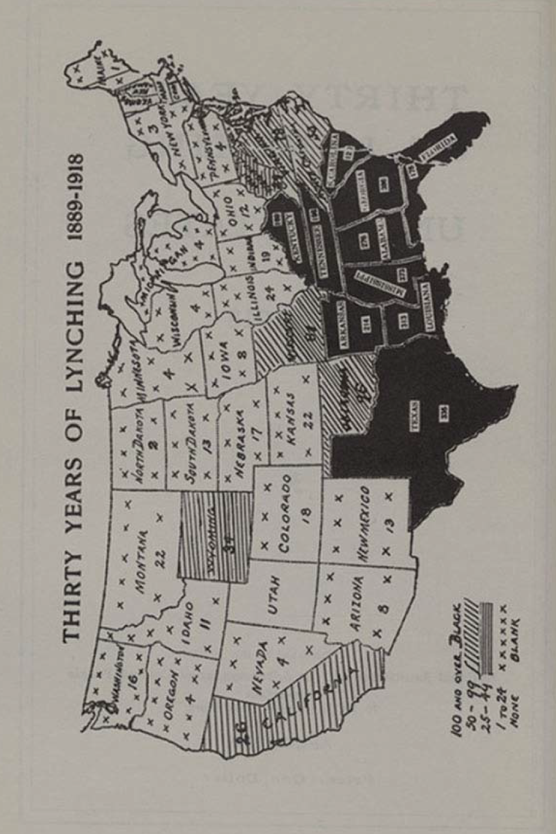

(NAACP, retrieved from Library of Congress)

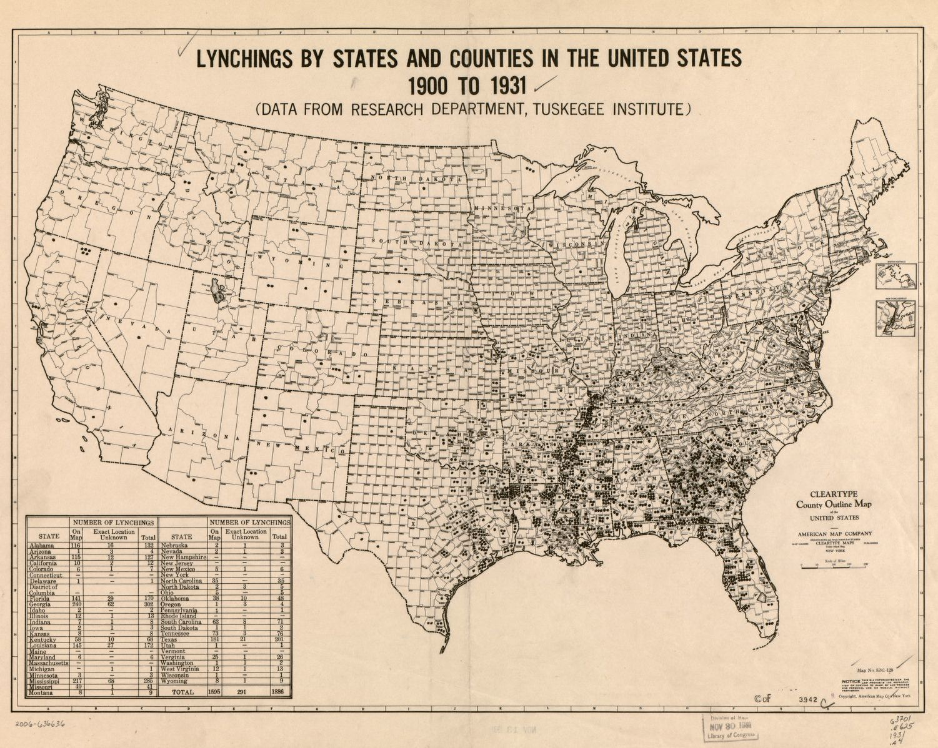

(map by Research Department, Tuskegee institute; retrieved from Library of Congress)

Appendix 2

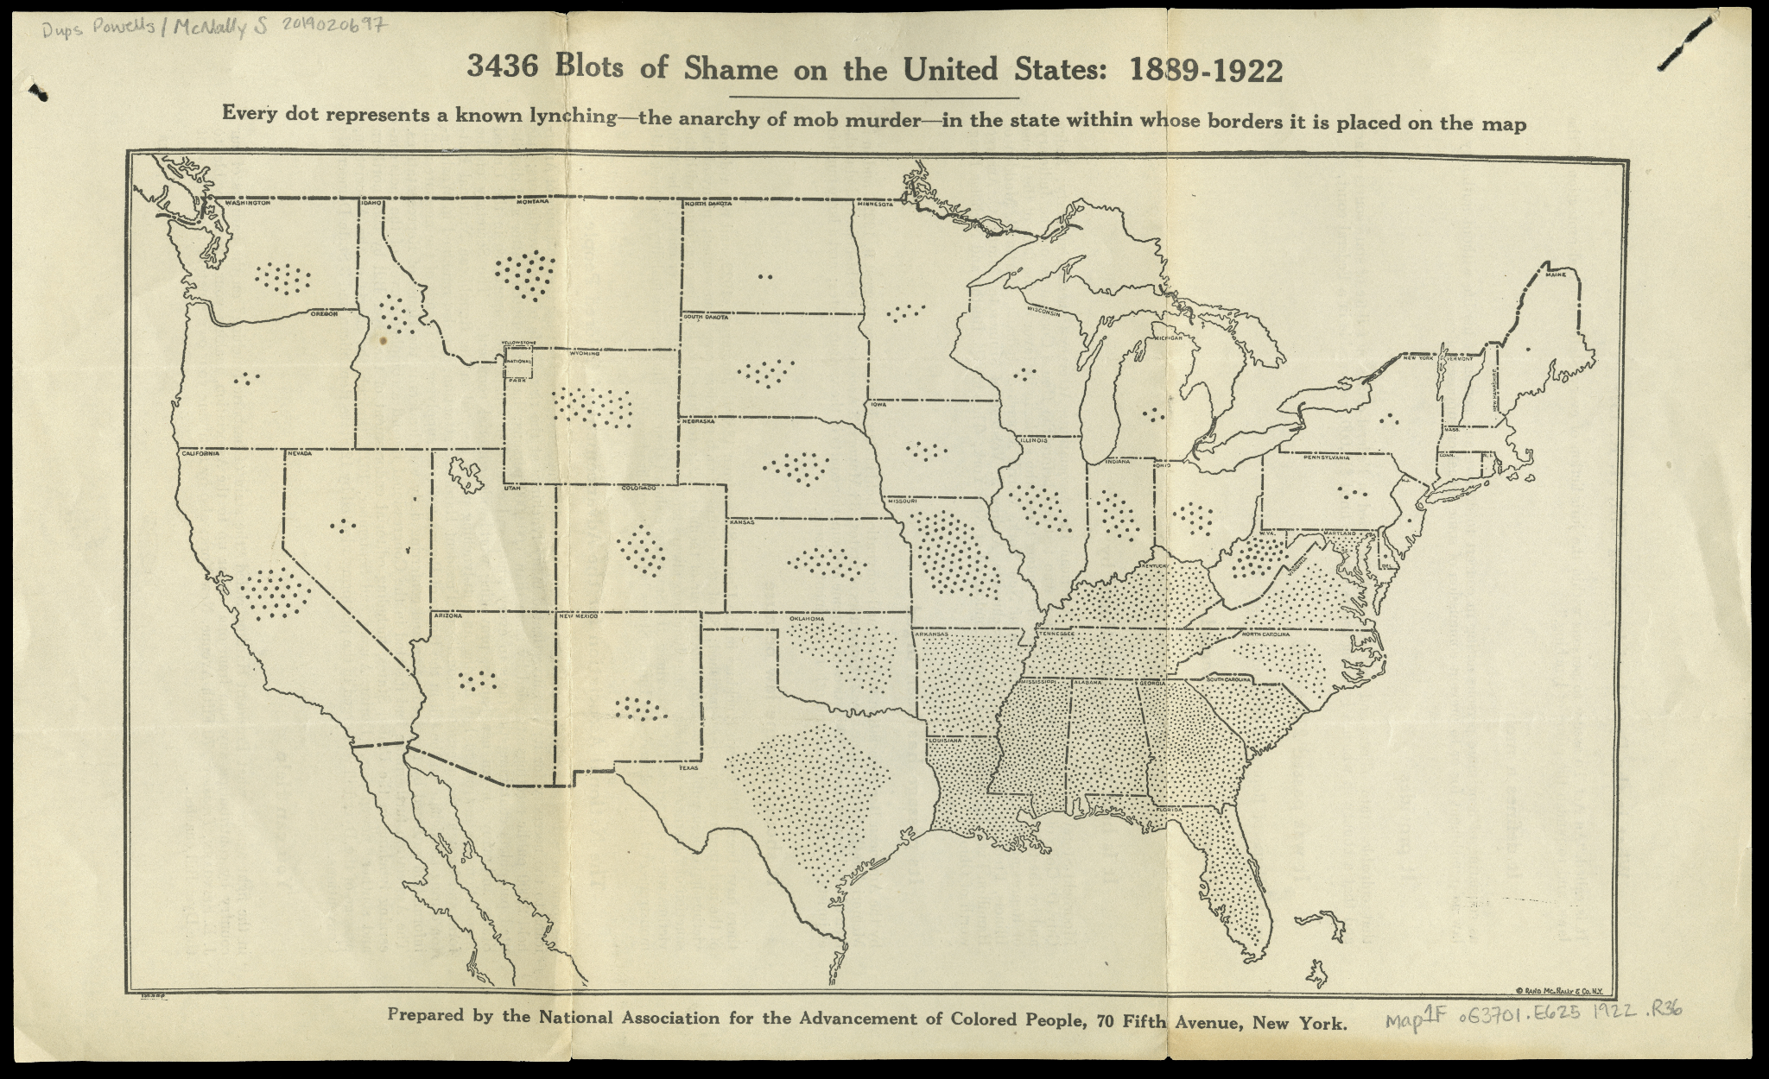

(Produced for NAACP, published by Rand-McNally)

Appendix 3

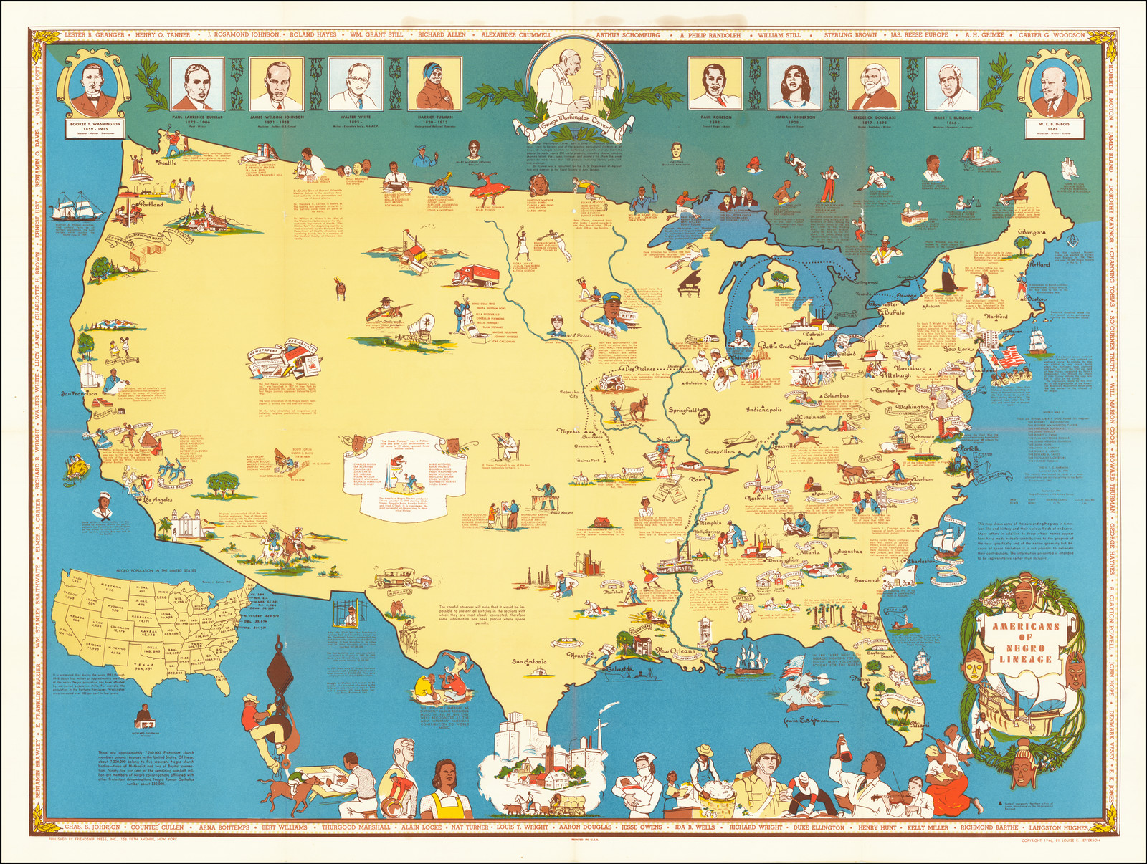

Appendix 4

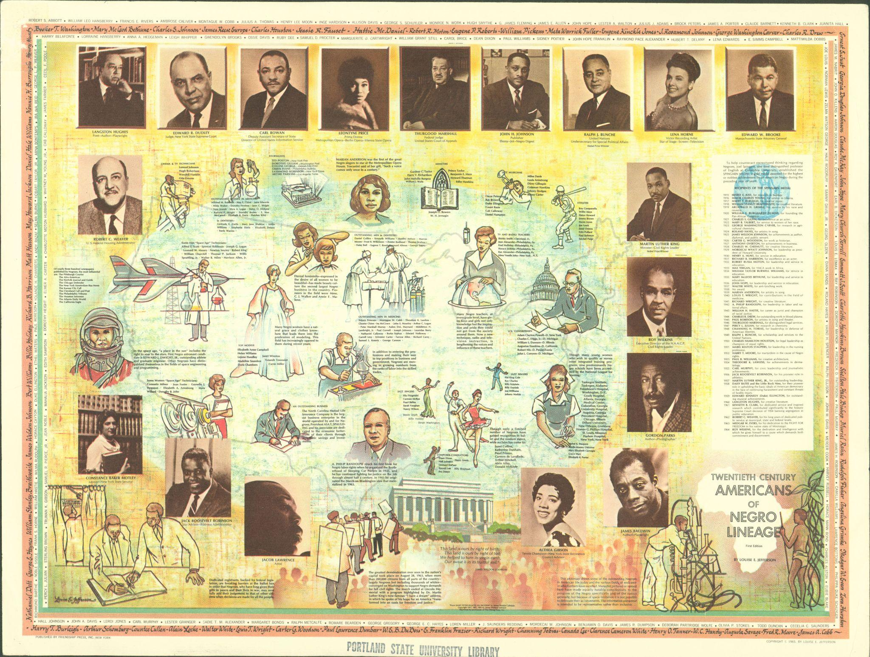

1. Accessible at <https://lynchinginamerica.eji.org/>